**Convolutional Neural Networks Classifying Dogs and Cats**

Michael Stewart

Colorado State University Global

CSC580-1: Applying Machine Learning and Neural Networks - Capstone

Professor Isaac Gang

October 27th, 2024

**Convolutional Neural Networks Classifying Dogs and Cats**

In this assignment, I created a convolutional neural network that classified images of dogs and cats. In order to do this, I started loading the data imaged below.

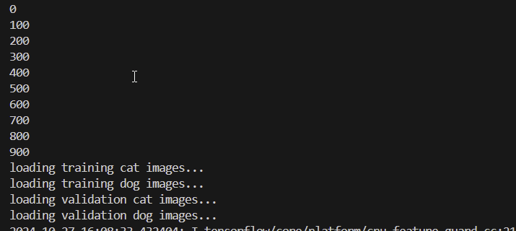

Then once we had the training data loaded, I trained a 24-kernel convolutional neural network on the data. I got a correlation value of 0.17 which is a little bit better than the bad result of zero. Then once that model was done I wanted to add more complexity to see the results of the correlation. The goal is for the correlation to be closer to 1. Once I added a second layer then I reran the model and got a much better correlation value.

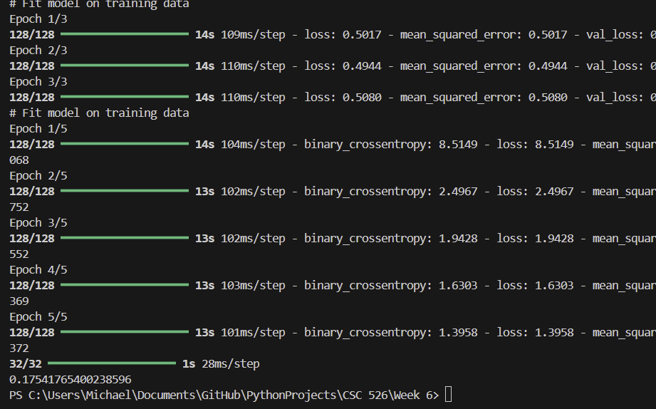

**0.17541765400238596 first correlation**

**0.4129634996478066 second correlation**

Then I added a scatter plot of the model’s performance. On the X-axis I plotted the predictions for each image, 0 being a dog and 1 being a cat. Then on the Y-axis, I plotted if the image was 1, a cat, or 0, a dog. The dots were layered on top of each other so it was hard to see how many dots were near 0,0 and 1,1. I added some jitter along the Y value of the samples. This means that the dots are actually only on the Y=1 and Y=0 lines, but I added a little bit of jitter to see them better. You can see that there is a good amount of dots at 0,0, 1,0, and 1,1. This means that there are dogs that look a lot like cats, but there are not a lot of cats that look like dogs. The model then is able to distinguish really well if the confidence that it is a dog is high, but it cannot distinguish well if it is a cat or not when the prediction is close to 0.

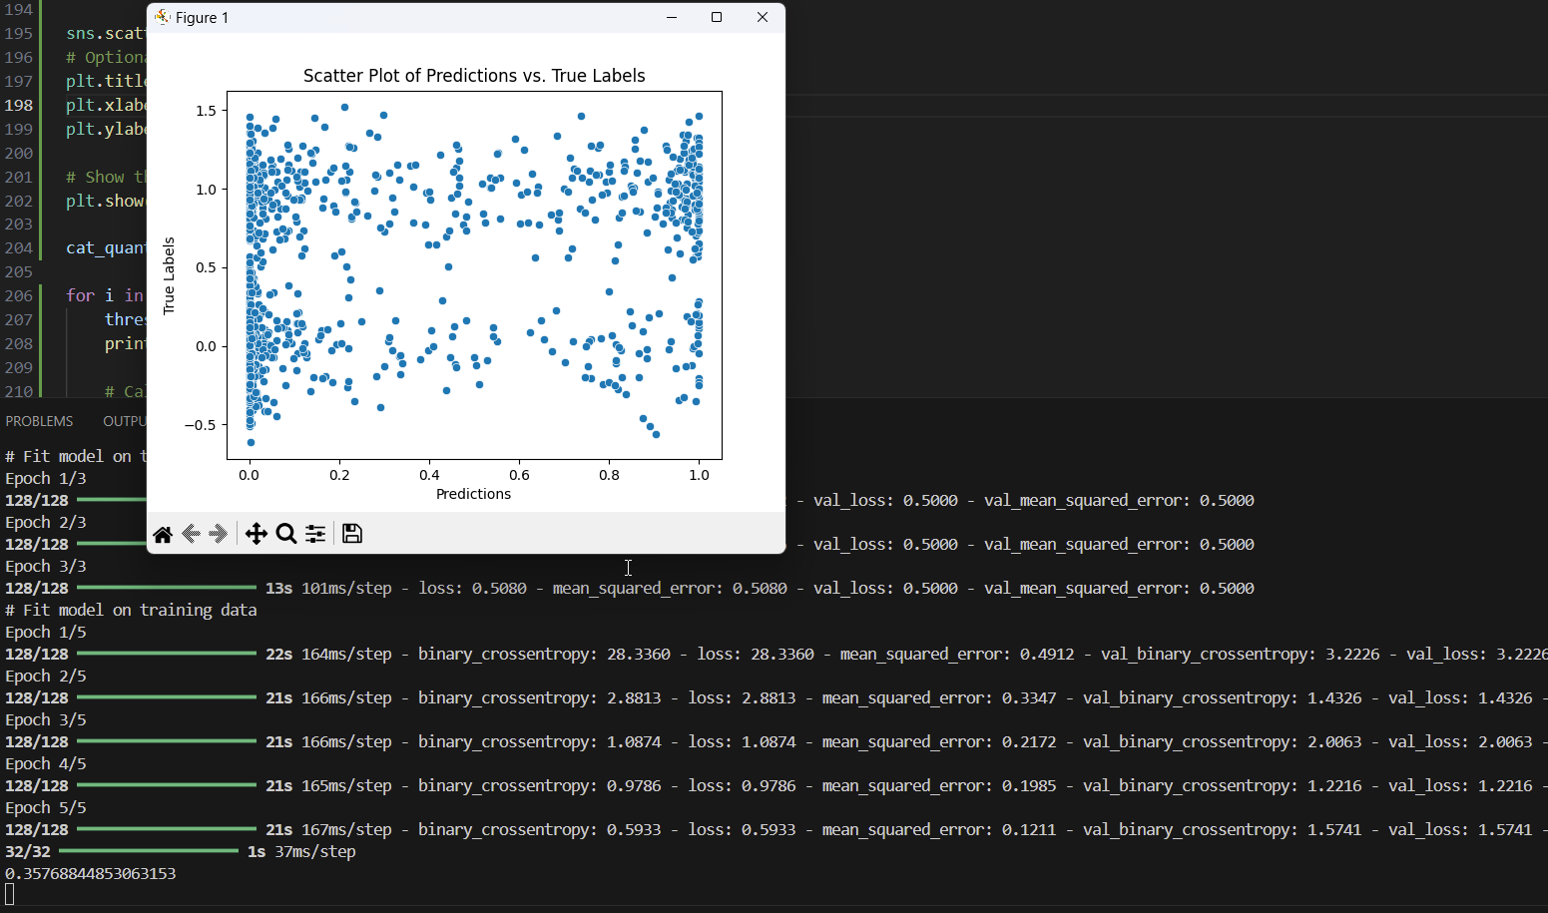

Finally, I added the ability for the user to input a specific index of photo and have the model show an image and prediction of its class. The results of this experiment showed a similar result to our scatterplot. There are lots of inaccuracies when the prediction is near 0, but much more accurate when the prediction is near 1.

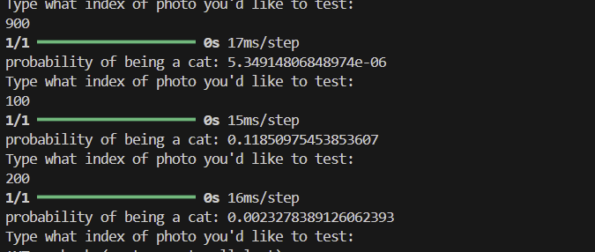

In order to make the model better, I would add another model after this one to process results that the model thinks are cats. I would train this second model on photos of dogs and cats that look very similar and hopefully, this model would specialize in this job. Then, the accuracy would be much higher with the two models in series.

**References**

Ganegedara, T. (2022). *TensorFlow in action*. Simon and Schuster.